Bay Area Homeschool Academy
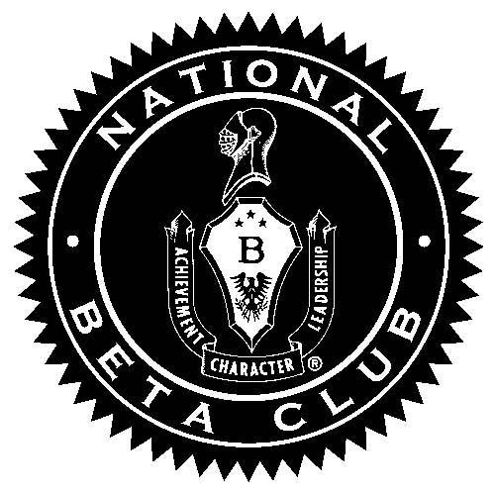
Beta Club
What is Beta Club?
Beta Club promotes character and social responsibility, by encouraging community and school service involvement. The National Beta Club recognizes and rewards outstanding achievement, fosters leadership skills, grants scholarships, and provides settings for your child to develop beyond the accolades of academic achievements alone. In an effort to shape and influence the future of our world, we are aiming to build up today’s students into tomorrow’s leaders.
What are the Student Qualifications?
To qualify, students must meet ALL of the following requirements:
- An overall 90 grade point average with no class average lower than an 85 in a grading period.
- Upstanding moral character on and off campus, with no behavior or attitude complaints from teachers.
- 3 letters of recommendations submitted for themselves, at least 1 being from a teacher (for new members only) (Letters of recommendations should be turned in at Study Hall Desk or emailed to Mrs. Boyd at: tarabethanyboyd@gmail.com)
Is there a fee to join?
Yes. A $40 fee includes: national & local membership, a certificate for new members, and a T-shirt. A check written out to Bay Area Homeschool Academy or Venmo sent to @BAHApay must be paid by our first meeting in September.

What is required of members?
- Students will be expected to attend the 9 monthly club meetings that will be held 8:00-8:30am on the first Thursday of each month during the school year.
- Members will be required to participate in 1 of the 2 service projects: One in Fall, One in Spring. Dates TBA.
- Students will need to attain a minimum of 6 personal service hours over the course of the school year (*Group service hours do not count towards personal service hours)
- All qualifying members will be included in an end of the year celebration.
How does a student maintain membership?
If a student does not maintain the grade point average of a 90 GPA, or has their average drop below an 85, is absent or tardy for more than 2 meetings (excused or unexcused), receives a discipline write up in class and/or does not meet the required amount of service hours, then the student will be dismissed from the Beta Club. Once a student is dismissed, they cannot regain membership for the current school year, but would have the chance to apply for membership again the following year if they wanted to.
Student Name: ______________________________________ Student Grade: __________
Student Cell: ______________________ Student Email: ______________________________
Parent Cell: ______________________ Parent Email: ________________________________
Circle One:
JR. BETA CLUB (Grades 6-8) SR. BETA CLUB (Grades 9-12)

I, __________________________________, have read the qualifications and requirements for BAHA Beta Club and understand what my commitment to joining this club means. I submit that my behavior and grades meet the standards of club membership and I look forward to being a Beta Club member.
X __________________________________ X _________________________________
Student Signature Parent Signature

